Project 4: Fund of Funds

Group 2

1. Background

In this project, we aim to analyze the historical performance on individual hedge funds in event-driven strategy from 1994 to 2006 and come out with a subset including five funds whose performance placed on the top five among all the funds in the pool over the next two years. Among the candidates, the candidate funds should be open for investments, launched for at least five years, subject to annual performance audits. They should have a lock-up period no longer than one year, and their returns should be denominated in US dollar. Besides, they should include leverage, and could not be one of the offshore vehicles.

To evaluate the performance of fund manager, regressing the fund portfolio returns against the pre-specified factor models and producing the so-called Jensen’s alpha is a commonly used technique. In this project, few famous models such as CAPM and Fama-French Three Factor models will be considered, along with tests of their feasibility and performance.

2. Quantitative Analysis

Among 539 candidates, we picked up 40 funds based on the criteria mentioned above.

During first step, we further eliminated 7 funds based on the following reasons:

There is no data available for 6 funds, which is impossible for the implementation of a quantitative analysis, hence they are excluded. Fund with code number 6608 ceased to report their performance after September 2005, which may indicate a worse than expected return, or in other words, investing in this fund is not a good choice, hence it is excluded from our candidate list.

For 33 remaining candidates, fund with code number 9645 reported quarterly at first, then changed its report frequency to a monthly basis; to ensure the consistency of our regression analysis, only the monthly return data is included.

For the second step, we used linear regression method based on few factor models to evaluate a set of given funds. The estimated intercept of the linear regression would be considered the excess returns with respect to the market, which is the determinant feature for our assessment. Furthermore, the significance of the outcome was checked through the value of t-statistics.

2.1 One Factor Model

The one factor model, or namely the capital asset pricing model, describes the relationship between systematic risk and expected return for some assets, particularly stocks. The formula for calculating the expected return is given as follows:

$$E\left[R_{i}\right]-R_{f}=α+β*(E\left[R_{m}\right]-R_{f})$$

We did regression analysis on (fund return - risk-free rate) with respect to (market return - risk-free rate), however based on the poorly adjusted R-squared, the model performed badly (see appendix 2), hence we need to pursue a better model.

2.2 Five-factor Model

Fama-French Three Factor Model is based on the CAMP by adding size risk and value risk factors to the market risk factors in the CAMP model. This model considers the statistical fact that value and small-cap stocks outperform markets on a regular basis. By taking these two factors into consideration, the model adjusts for this outperform tendency, which is thought to make it a better tool for evaluating and making assessment for manager performance. Also, by adding default and term premium for the same reason, we have the following formula:

$$E\left[R_{i}\right]-R_{f}=α+β_{1}*\left(E\left[R_{m}\right]-R_{f}\right)+β_{2}*smb+β_{3}*hml+β_{4}*dp+β_{5}*tp$$

The above model yields a result with better adjusted R-squared with a maximum value of 0.74, which is acceptable. We first picked 8 funds with significant t-statistics that has a positive alpha value. Also we observed that few funds with relative high return perform badly under five-factor model, hence two of them were picked through their historical steady performance.

The pool of potential investment candidates consisted of the final 10 funds chosen as above, which could be find in the appendix 3.

2.4 Performance Test

2.4.1 Auto-correlation Test

Due to the fact that the hedge fund are required to report frequently as they may not trade in intermittent periods, it is highly possible to be no market available prices at the reporting time. So that hedge fund managers may tend to price their funds that the returns are smoothed out to reduce the volatility and thus increase the Sharpe ratio which is the main measure of performance.

However we know that the extra return created through illiquid investment is just a compensation for illiquidity but not the true contribution due to the fund manager’s personal ability. Therefore, we need to perform an auto-correlation test on those candidates to further reduce the candidate number based on their liquidity condition.

After using autocorrelation, we shrink the size of candidates from 10 to 7, which are the following,

|  |  |
| --- | --- |
| Fund Code | Fund Name |
| 1934 | Catalyst Fund L.P. |
| 3003 | Langdon Street Capital, L.P. |
| 2073 | Catalyst Strategic Event Fund, L.P. |
| 3004 | March Capital Partners, L.P. |
| 919 | KDC Merger Arbitrage Fund, L.P. |
| 5632 | Riley Investment Partners Master Fund, L.P. |
| 18075 | Barington Companies Equity Partners, L.P. |

The detail of this part would be found in appendix 4.

2.4.2 Sharpe Ratio

In order to get the final 5 candidates, we ranked the 7 funds based on their Sharpe Ratio, which could be explained as the average return in excess of the risk free rate per unit of volatility, or equivalently per unit of risk. Subtracting the risk free rate from the mean return allows the investors to better isolate the profits associated with risk-taking activities.

3. Result

Based on the above analysis, we provide the 5 candidate funds for investment. They are listed as follows:

|  |  |
| --- | --- |
| Fund Code | Fund Name |
| 1934 | Catalyst Fund L.P. |
| 3003 | Langdon Street Capital, L.P. |
| 2073 | Catalyst Strategic Event Fund, L.P. |
| 3004 | March Capital Partners, L.P. |
| 919 | KDC Merger Arbitrage Fund, L.P. |

Appendix

1. Online spreadsheet containing data and calculation process is available here

<https://docs.google.com/spreadsheets/d/1ssCRRCSX7M7Hf7DzEkDWbxSIN1MZPD17T3nvwSn3H8s/edit?usp=sharing>

2. CAPM result

Please see the sheet named “factor + fund” in above online spreadsheet, the CAPM result for all 34 funds are located in row 162 to line 166 and column Q to column AW and are marked with green background color.

3. 10 fund pool

|  |  |
| --- | --- |
| Fund Code | Fund Name |
| 5172 | Robeco WPG Ericott Merger Arbitrage Fund, L.P. |
| 7879 | Highland Crusader Fund, L.P. |
| 1934 | Catalyst Fund L.P. |
| 3003 | Langdon Street Capital, L.P. |
| 2073 | Catalyst Strategic Event Fund, L.P. |
| 3004 | March Capital Partners, L.P. |
| 919 | KDC Merger Arbitrage Fund, L.P. |
| 5632 | Riley Investment Partners Master Fund, L.P. |
| 18075 | Barington Companies Equity Partners, L.P. |
| 6685 | Harbinger Capital Partners Fund I, L.P. |

4. Autocorrelation test result

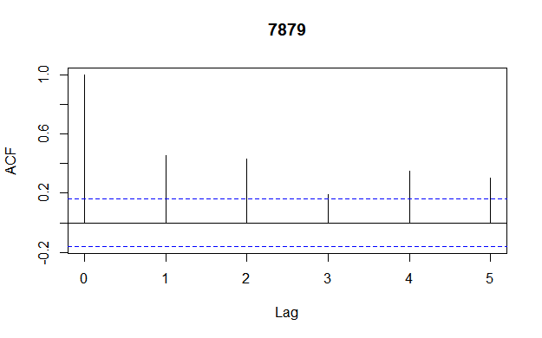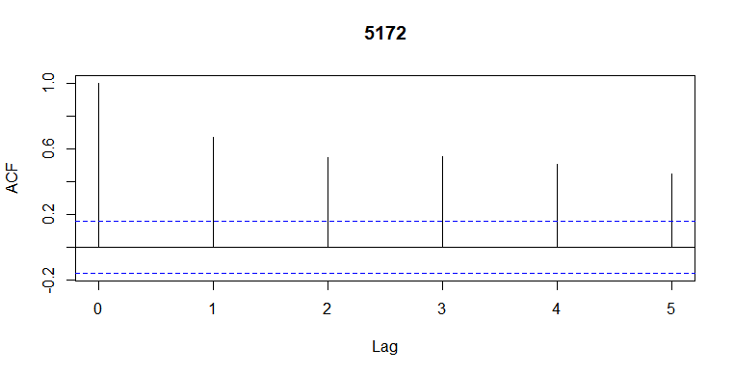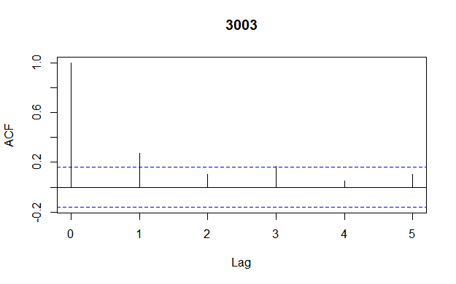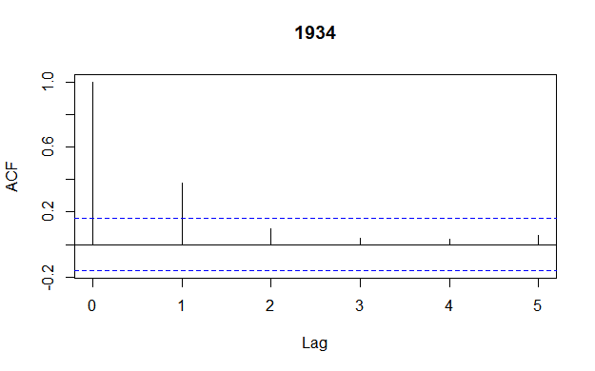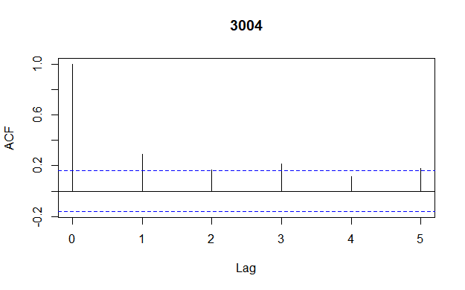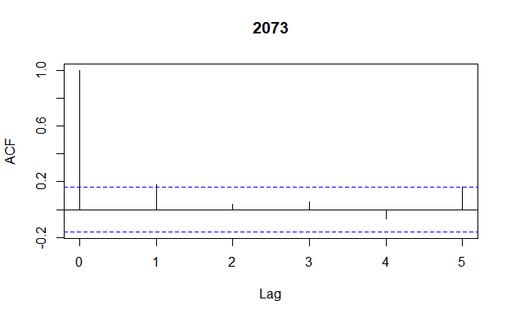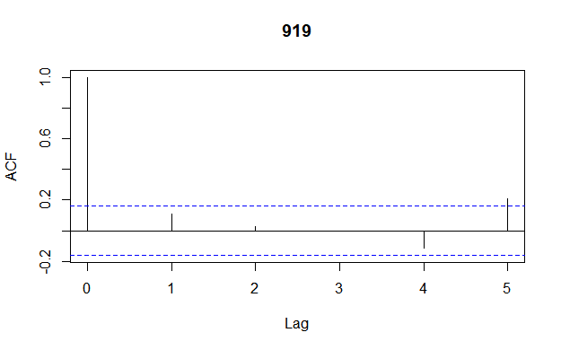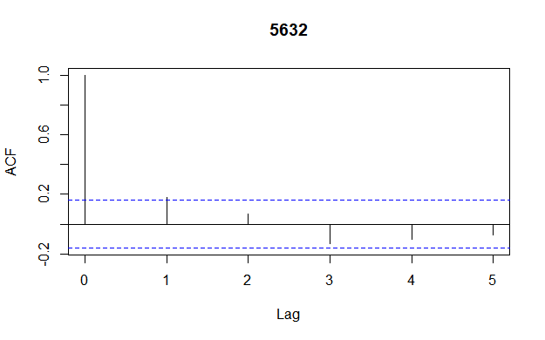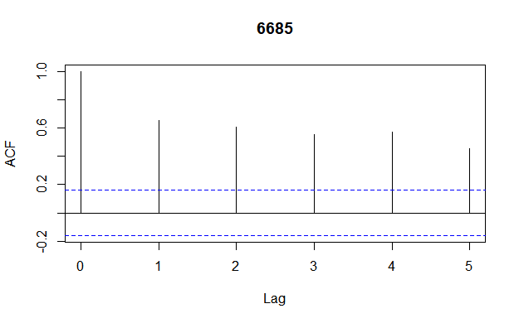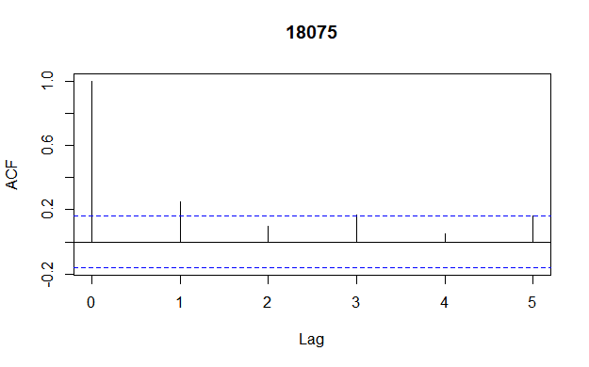

The ACF results are as above, finding that for company 5172 7879 and 6685, it shows that there are great autocorrelations for their returns with lag 5. Thus we drop these three companies because high autocorrelations imply that their funds may have illiquidity issues and thus the performance results are unrealiable.